Task 3 Project Website Content

Existing System Conditions
The following provides an overview UPTD’s existing services, ridership trends, and budget and costs. For more information on the existing system conditions, please see the full Memo 1: Existing System Conditions.

Existing Services
Table 1 summarizes each Douglas County transportation provider by the provider type (public or private), type(s) of service, operating hours, and general service areas. Figure 1 a service map of services provided in the county and Figure 2 shows a service map of services in the Roseburg area.
Figure 1: UPTD Douglas County Service
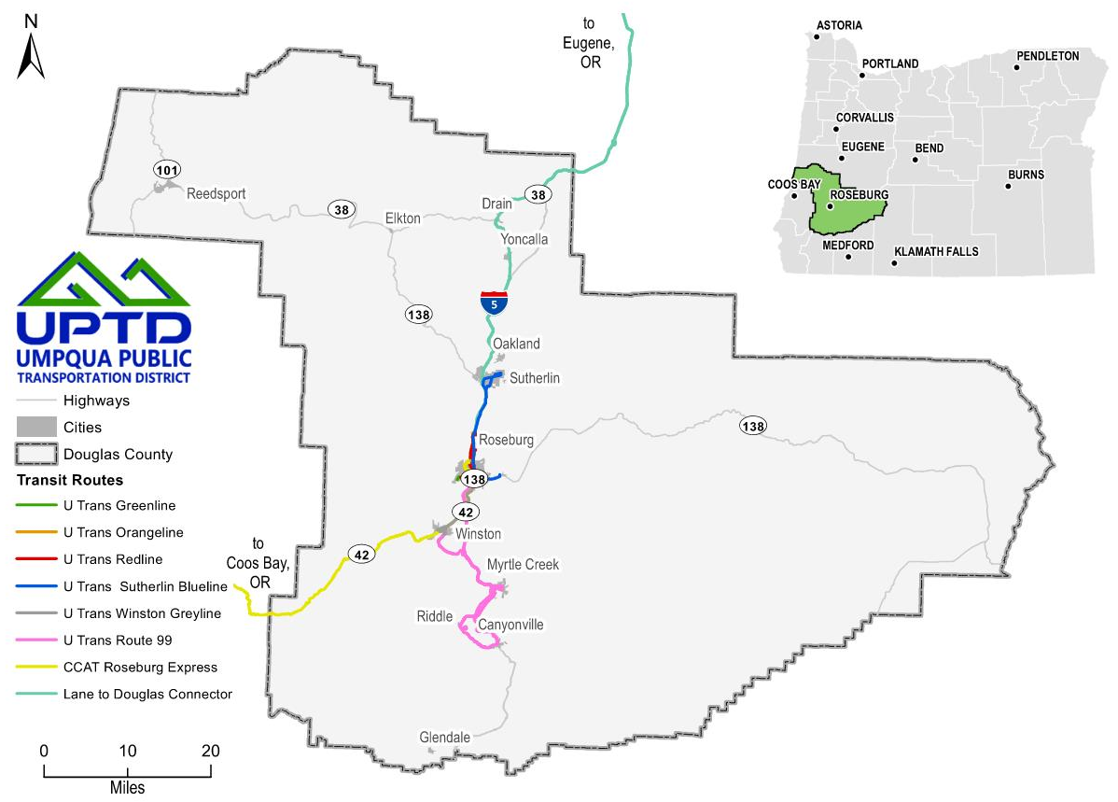
Figure 2. UPTD Roseburg Service
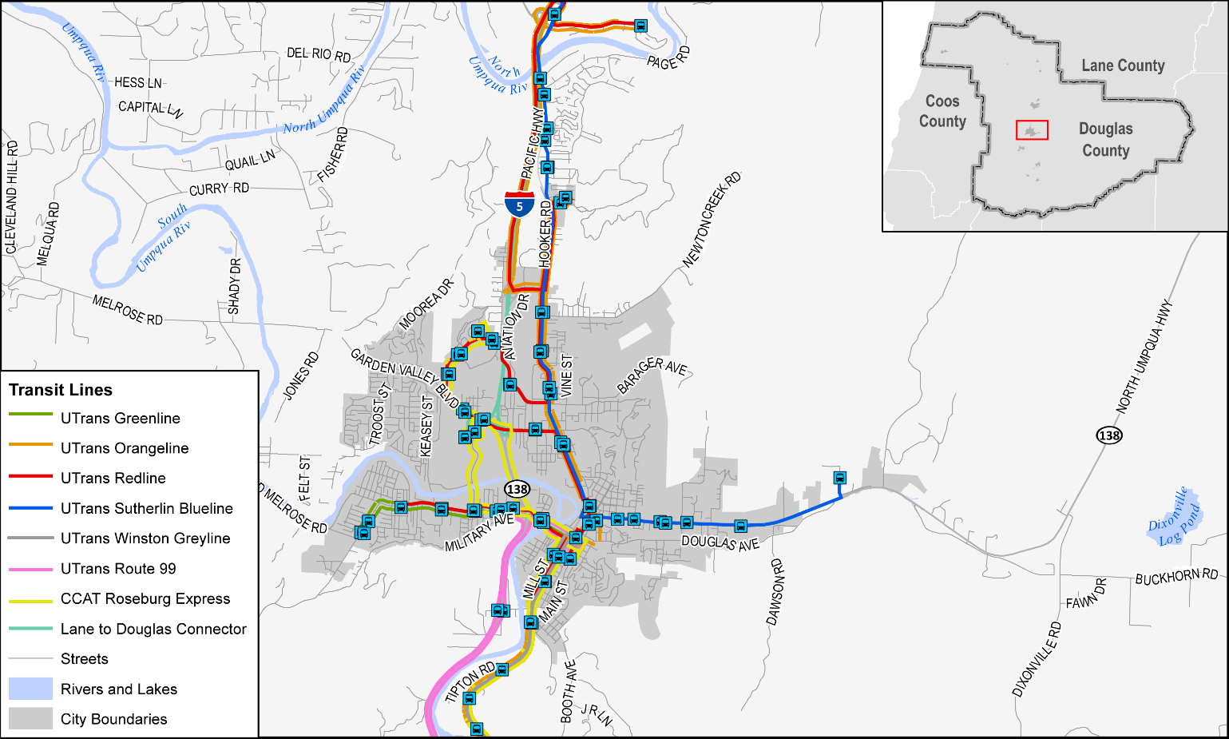
Table 1. Transportation Service Options for Traveling within Douglas County
Transportation Provider | Public / Private | Service Type | Operating Hours | Service Area
UTrans (UPTD) | Public | Fixed-Route | 6:30 AM – 7:30 PM weekdays  8:15 AM – 6:30 PM Saturday | Douglas County
UTrans Direct (UPTD) | Public | Paratransit | 6:15 AM – 8 PM weekdays | City of Roseburg  Within ¾ air mile of UTrans fixed-route service
Umpqua Rides (UPTD) | Public | Demand-Response | 8:30 AM – 4:45 PM weekdays | Douglas County
South Lane Wheels | Public | Deviated Fixed-Route | 2 round trips,  Tuesdays and Thursdays | Lane – Douglas Connector (Roseburg to Eugene)
Coos County Area Transit (CCAT) | Public | Fixed-Route | 1 round trip,  Tuesdays and Wednesdays | Coos Bay to Roseburg
 |  |  | 3 round trips, Mondays, Tuesdays, Thursdays, Fridays | Coos Bay to Florence, with stop in Reedsport
Greyhound | Private | Fixed-Route | 2 trips per direction  6:30 AM – 11:30 PM  7 days a week | I-5 corridor, stopping in Roseburg
DC Sunshine Taxi & Courier | Private | Taxi: Demand-Response | 24/7  7 days a week | Greater Roseburg area
Sources: Umpqua Public Transportation District, South Lane Wheels, DC Sunshine Taxi & Courier

Ridership Trends
Figure 3 shows the average number of rides per hour and the total annual ridership between 2013 to 2019 across all services (fixed-route and demand response). During this time period, UPTD served an average of 4.5 rides per hour and provided 169,463 rides annually. UPTD provided approximately 5.5 rides per hour on its fixed-route services and 99,000 annual rides in 2019. The downward ridership trend since 2014/2015 is consistent with national transit ridership trends.
Figure 3. UPTD Average Rides per Hour

Source: NTD
Figure 4 shows the total ridership by month between 2016 to 2021. As shown, ridership is typically highest in October, with other ridership peaks in the spring and summer. The decline in ridership starting in March 2020 is attributable to the COVID-19 pandemic and stay-at-home orders.
Figure 4. UPTD Monthly Rides by Year

Source: UPTD

Budget and Costs
Table 2 shows the annual cost allocations for UPTD by expense type. As shown for Fiscal Year 2021 (FY21), operations expenses accounted for the majority of expenses at about 75% of the budget without capital improvements.
Table 2. 2021-2022 Cost Allocation by Expense Type
 | Operations | Administration | Maintenance | Total (without Capital) | Capital
Allocation Amount | $2,856,310 | $797,750 | $177,140 | $3,831,200 | $30,000
Percent of Budget | 74.6% | 20.8% | 4.6%
The $3,591,050 in funding available to UPTD in 2021-2022 came from federal, state, and local sources. Figure 5 shows the amount provided from each of the three sources. Federal funding was by far the largest contributor, including a $450,000 Coronavirus Response and Relief Supplemental Appropriations Act (CRRSAA) Grant. The CRRSAA Grant is not expected to be provided in future years. Other federal funding included formula grants, which are anticipated to remain stable in future years. State funding sources are largely the Special Transportation Fund (STF) and Statewide Transportation Improvement Fund (STIF). Local sources include fares, contract revenues, and advertising.
Figure 5. Funding Type
Source: UPTD, excludes cash carryover from previous years.

Goals and Policies
The following goals and policies will help guide the development of appropriate strategies to enhance transit service, facilities, and amenities in Douglas County. See Memo 2: Transit Goals, Policies, and Practices for more information on how they were developed.
- Goal 1. Provide improved transit services for residents, employees, and visitors throughout Douglas County.
- Policy 1.1. Prioritize improvements for transit-dependent people, including low-income populations, people with disabilities, zero-vehicle households, communities of color, older adults, youth, and people with limited English proficiency.
- Policy 1.2. Improve transit frequency and reliability for existing fixed-route, paratransit, and demand-response transit services.
- Policy 1.3. Expand the geographic coverage of Douglas County’s fixed-route, para-transit, and demand-response transit services.
- Policy 1.4. Connect to activity centers, schools, government centers, grocery stores, pharmacies, and other community resources.
- Practice: Establish an evaluation framework and monitoring program that considers service to transit-dependent populations, thresholds for frequency improvements, reliability and on-time performance tracking, and triggers for new geographic coverage.
- Goal 2. Enhance coordination with key partners and stakeholders.
- Policy 2.1. Foster new and innovative partnerships to share and leverage resources, improve services, and further create awareness of UPTD in the community.
- Policy 2.2. Collaborate with local governments and connecting transit providers to ensure transit service meets the needs of riders.
- Policy 2.3. Form partnerships with key stakeholders and establish ongoing feedback channels to improve customer service.
- Practice: Meet regularly with cities, connecting transit providers, employers, community-based organizations, and other key stakeholders to discuss transit needs.
- Goal 3. Promote livability and user convenience throughout Douglas County.
- Policy 3.1. Provide community betterment and beautification through increased transit infrastructure and service, including bicycle and pedestrian connections to bus stops and improved bus stop amenities.
- Policy 3.2. Prioritize strategies to reduce single-occupancy vehicle trips, such as pursuing bus-on-shoulder operations to make transit a competitive alternative to driving alone.
- Policy 3.3. Monitor demand from smaller communities and consider improvements to north–south service as communities continue to grow.
- Practice: Develop transit service opportunities that improve inter-county and intra-county connectivity and enhance bus stop access and amenities, including bicycle storage at stops.
- Goal 4. Establish an environmentally and financially sustainable transit system.
- Policy 4.1. Pursue clean fuel for transit vehicles, such as electrification of the future vehicle fleet and infrastructure.
- Policy 4.2. Foster financial sustainability by establishing stable local funding sources to supplement existing sources.
- Policy 4.3. Identify a range of future service opportunities that can be ready to take advantage of grant funding opportunities, such as those focused on capital improvements, service reliability, recreation/tourism, and/or geographic coverage.
- Practice: Collaborate with local jurisdictions to incorporate electric vehicle or other clean energy infrastructure throughout Douglas County in preparation for a future fleet.
- Practice: Monitor opportunities for new grant sources and new local funding sources, such as an employer tax, bonds, or other new sources.

